Implementation of PaaS

**Launch Docker on AWS Beanstalk:**

1. Visit <https://aws.amazon.com> and login to your AWS account.
2. Select **Services** from top right header.
3. Click on **EC2**. (Before launching Docker on Elastic Beanstalk, we need to create key to access the instance which will be created after launching the application in Beanstalk. Also we need to create security group in EC2 section to make the instance accessible globally.)

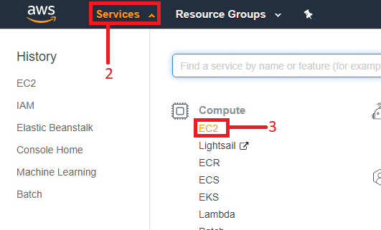

1. Click on **Security Groups**.

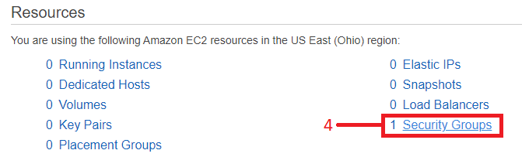

1. Create Security Group to allow ports and IPs to access the instance.

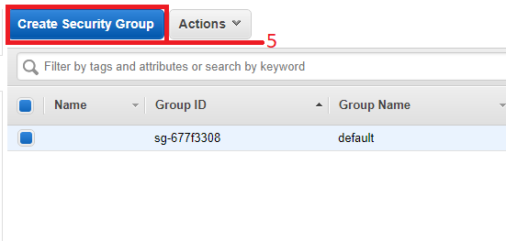

1. Give name to the **Security Group**.
2. Enter d**escription** for your reference.
3. Add Rule to allow the ports.
4. Choose **all traffic** to allow all ports/protocol.
5. Choose Source **Anywhere**.
6. Click on **Create** to create the Security Group.

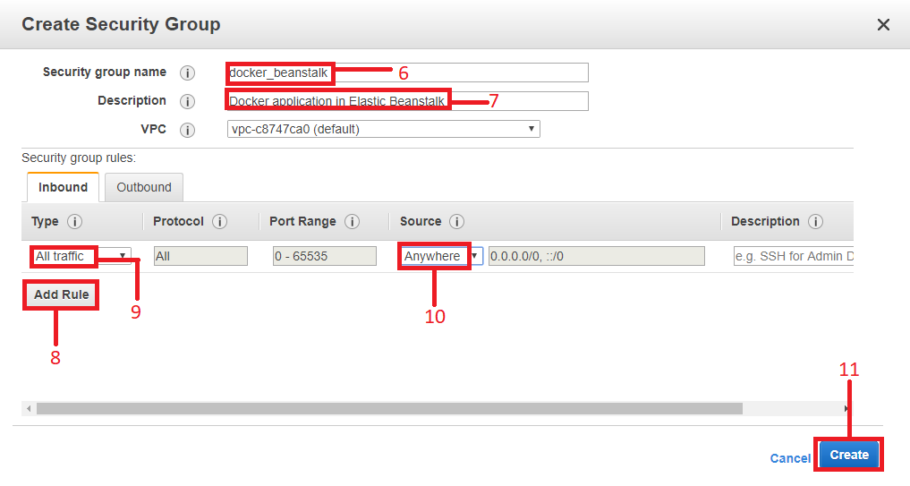

1. Scroll down in Left side menu and click on **Key Pairs** to create the key.

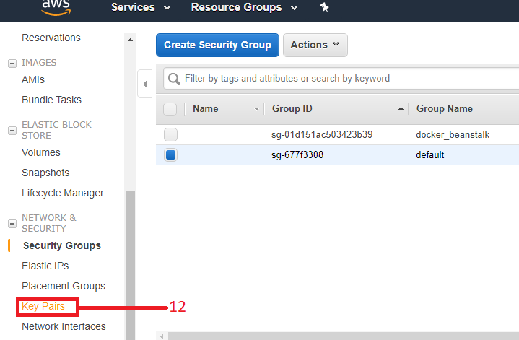

1. Click on **Create Key Pair**.

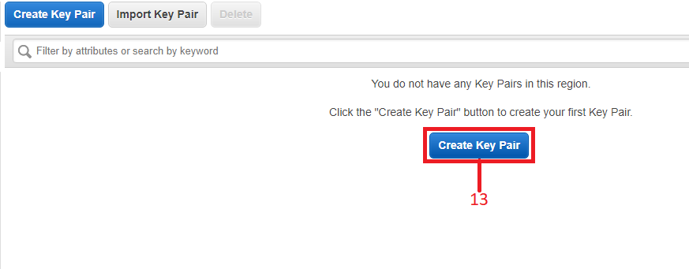

1. Enter name for the **Key pair**.
2. Click on **Create**. (This will automatically save the key into your local system. Keep it and don’t delete it because this key is important to access the instance that will be created after launching the Elastic Beanstalk application.)

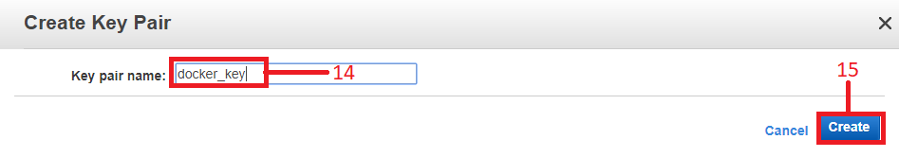

1. Click on the **Services** on top menu bar.
2. Select **Elastic Beanstalk**.

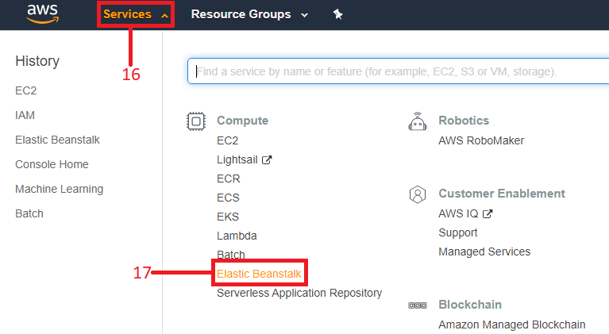

1. Click on **Get Started** to launch the application using Beanstalk.

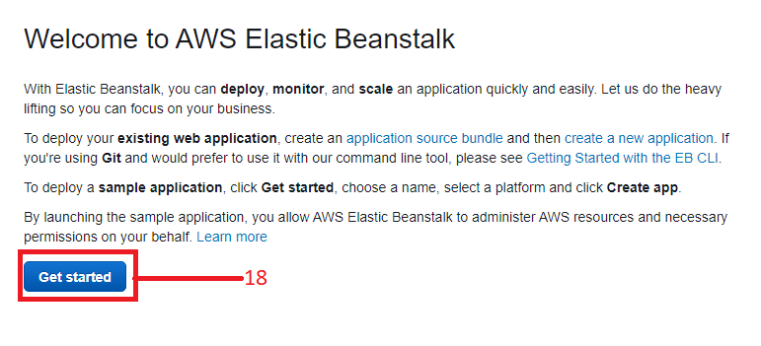

1. Enter any name for the application in **Application name** option.
2. Select **Platform** which you want to create. (Here we are going to launch the Docker.)
3. Click on configure more options to assign key pair and security group which we have created in previous steps.

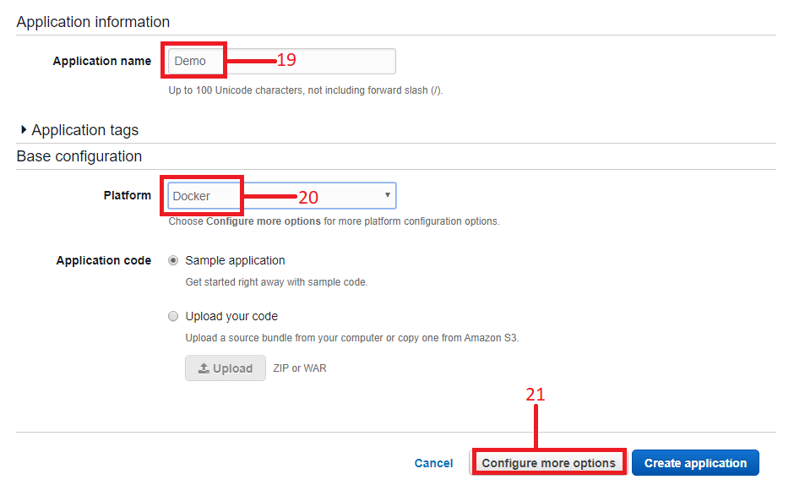

1. Choose **Configuration presets** to **Low cost ( Free Tier eligible)**
2. In Instances box click on modify.
3. Tick on the security group which we have created in previous steps.
4. **Save** the Configuration.
5. In Security box click on the **modify** option.

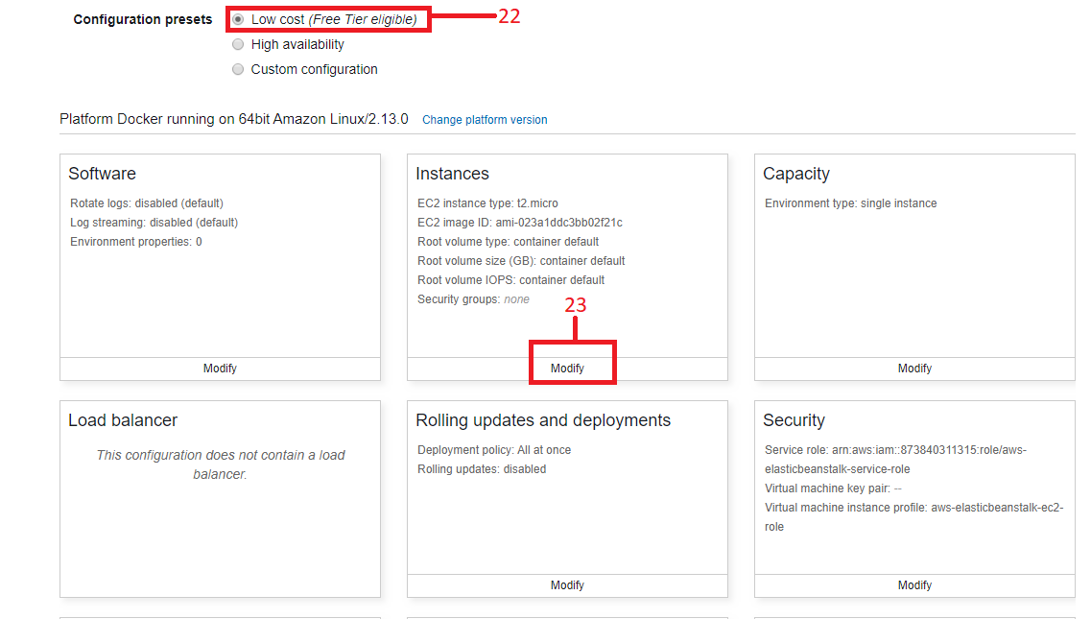

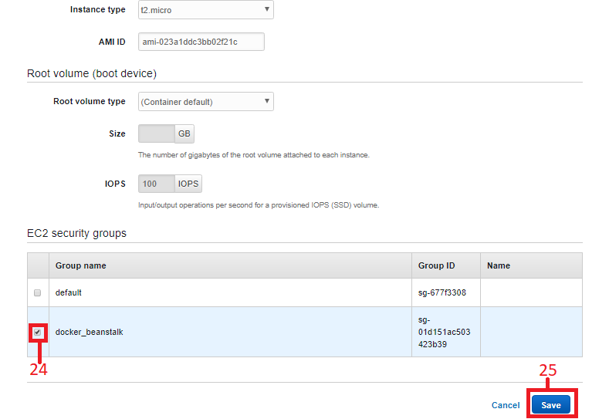

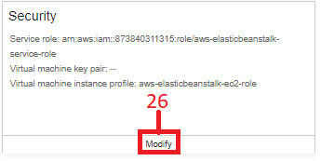

1. Select **key pair** which we have created in step 14.
2. **Save** the security settings.

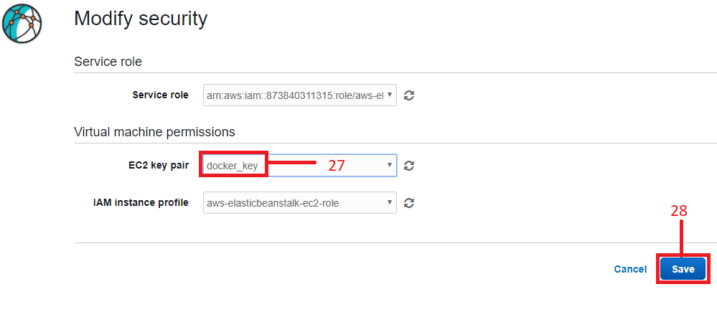

1. Modify the Network Setting.

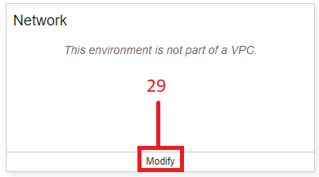

1. Select availability zone which we want to use. (Here we are going to select all availability zones.)
2. Save the setting.

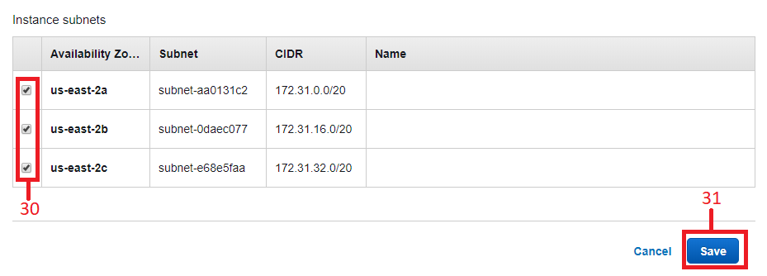

1. **Create app**, this will take some time to launch the beanstalk application.

(**Note:** Whenever you launch any application it automatically creates its instance in AWS EC2 and also creates an AWS S3 Bucket.)

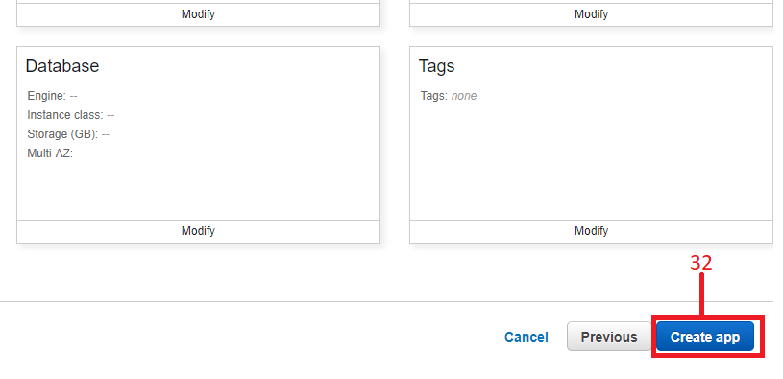

1. To check whether your application is created or not copy and paste **URL** in new tab which you will get.

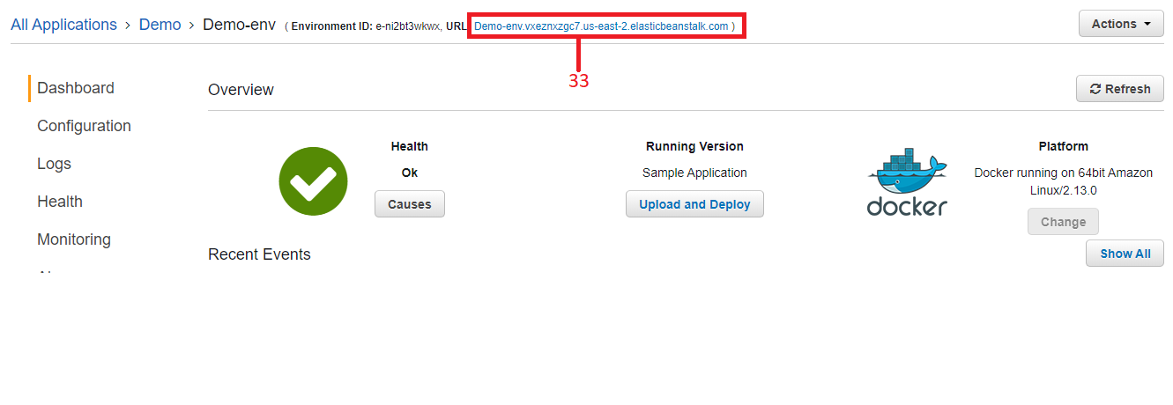

1. If URL shows **congratulation** message means you have successfully launched Beanstalk application.

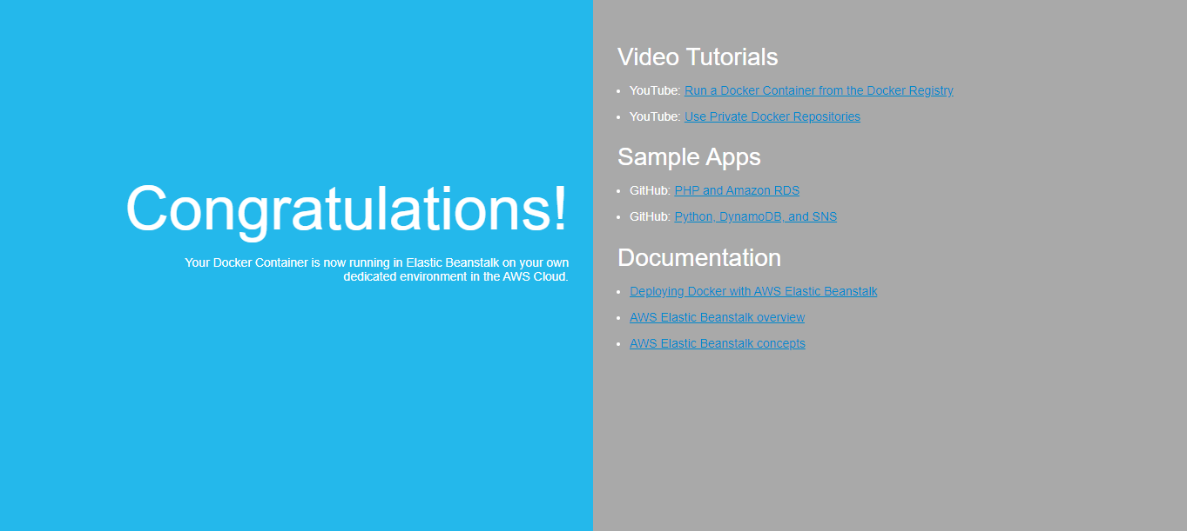

1. Close URL or go back to AWS Tab and click on **services** and choose **EC2** again to find whether the instance is created or not.

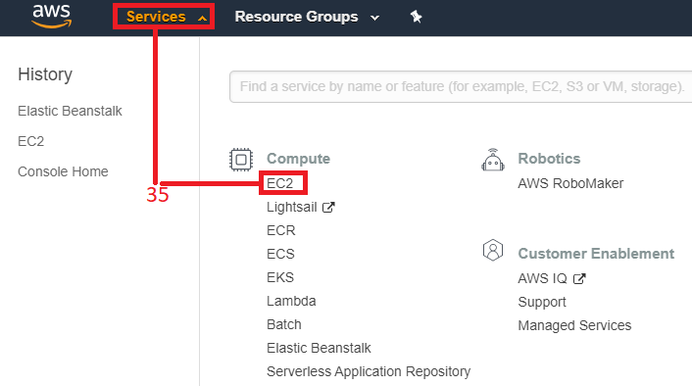

1. In Resources section you will find new **Running instance** by access that you will be able to access Docker.

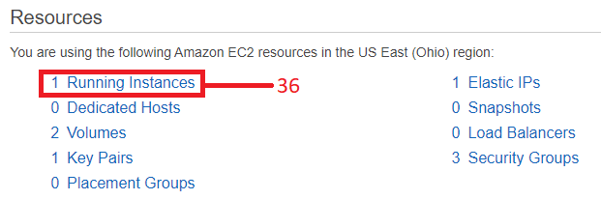

1. Click on the connect option to get login details to access the Instance using mobaxterm.

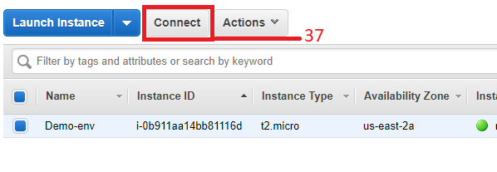

1. Here you will get username to access the instance, and close connect popup window.

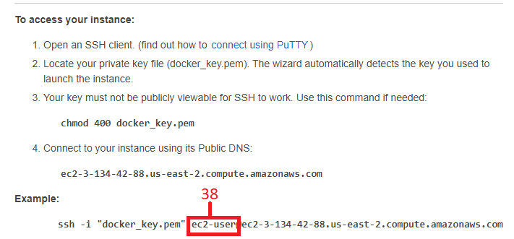

1. Tick on the instance which you want to access.
2. Copy the IPv4 address of the instance. And open mobaxterm application and enter details to access the instance.

(**Note:** to access the instance using the mobaxterm application you can refer IaaS implementation PDF)

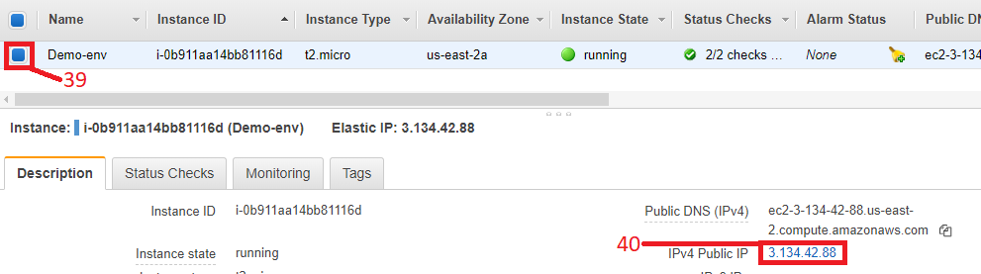

1. After accessing the instance on mobaxterm, it will look like this.

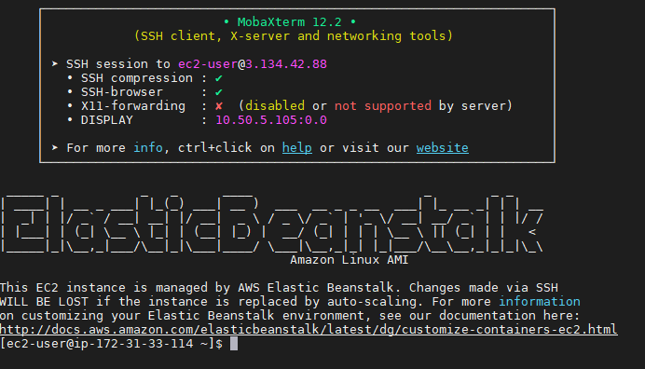

**How to delete the AWS Beanstalk Instance:**

1. Click on the **Services** and choose **Elastic Beanstalk**.

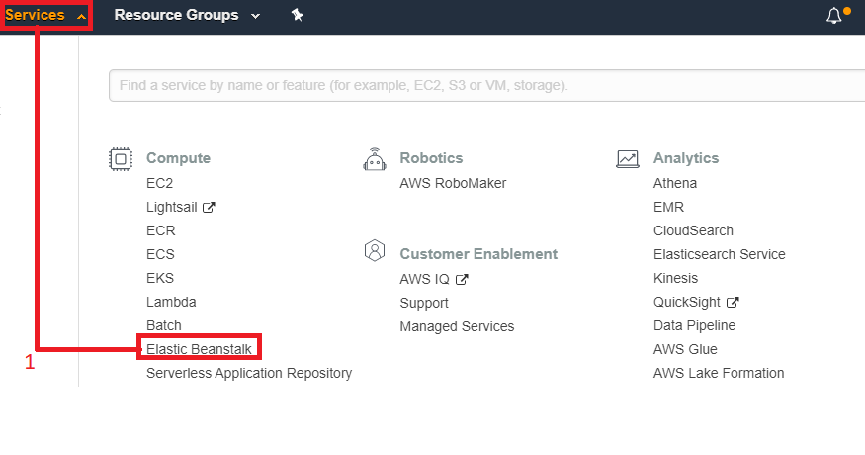

1. Click on **Actions**.
2. Choose **Delete application,** new popup will be appear simply enter application name into it and delete the application.

(**Note:** This will take some time to delete the application, you can also click on green box, here you will get environment terminating notification. Wait until the server gets terminated)

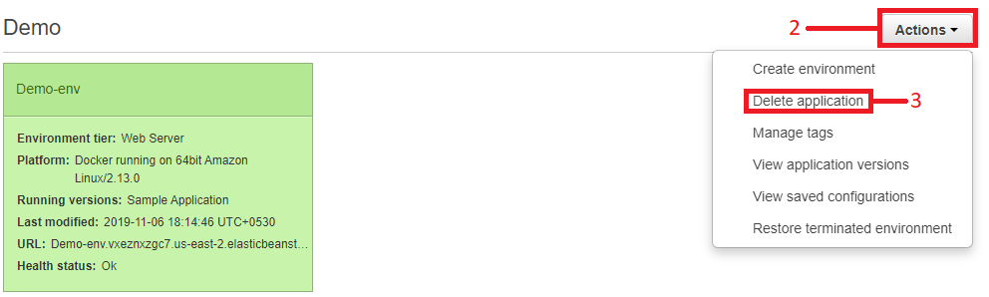

1. After deleting the application confirm that instance is also terminated or not by going to Services >> EC2 >> Running Instances. And S3 bucket will not be deleted because you don’t have enough access to delete the bucket. To delete the S3 bucket click on services and then choose S3.

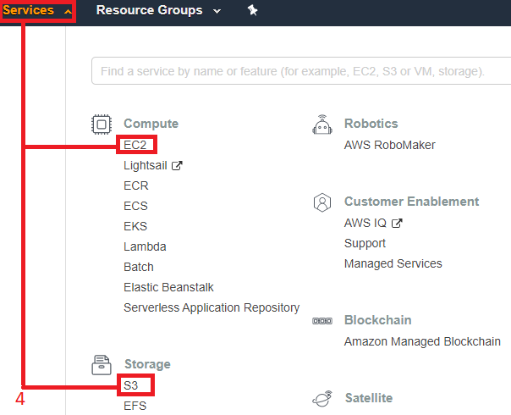

1. Click on the beanstalk’s bucket name which you want to delete.

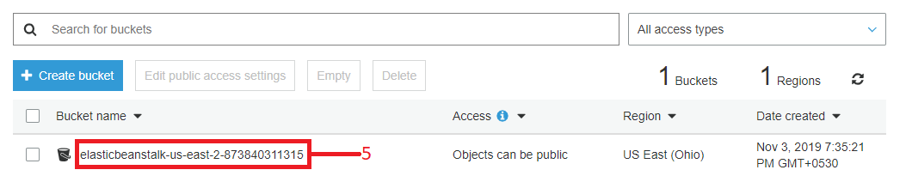

1. Click on **Permissions**.
2. Select **Bucket Policy**.
3. Replace **Effect** from Deny to **Allow** and Save the Policy.

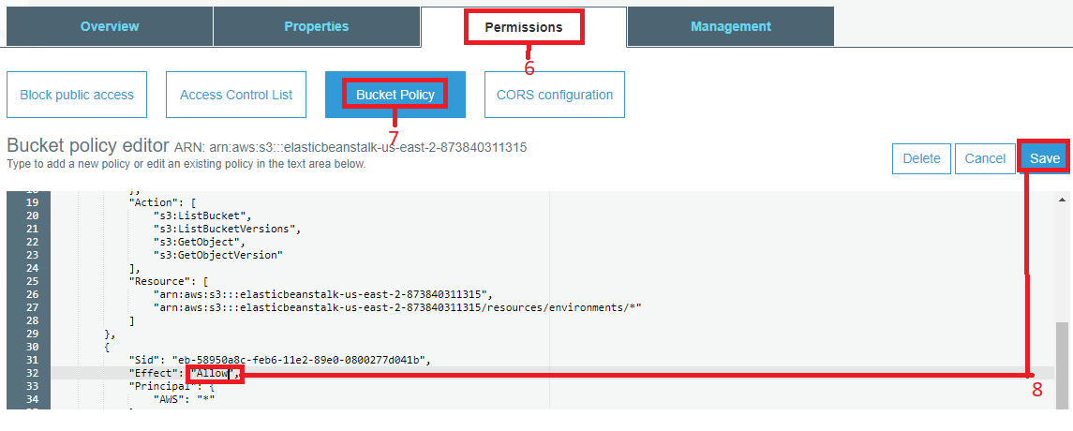

1. Click on Amazon S3 in top left corner.

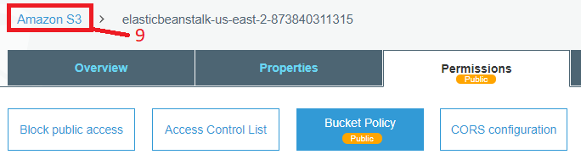

1. Tick on S3 instance.
2. Click on **Delete**.

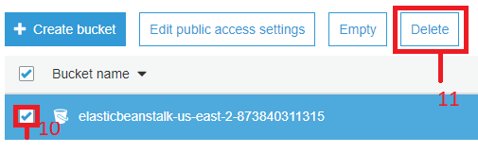

1. Copy bucket name from here.
2. Paste bucket name.
3. Click on **Confirm**.

